Library Schedule
Black​ font comes every week​.Blue​​ ​font comes every other week. ​Orange​ ​font Library is closed.​Green​ ​font AR checkout times.
GameWeeks: ​Oct 15-19,Nov 26-30,Jan 14-18,Feb 25-28,and ​April 22-26​ is the​ ​last​ game week of the year. Library closes ​May10th

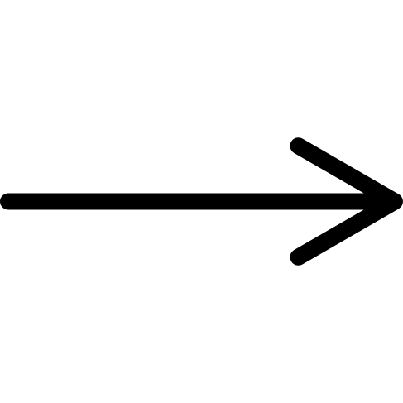  Periods  Days of week | 8:00-8:48  1st period | 8:52-9:40  2nd period | 9:44-10:32  3rd period | 10:36-11:24 4th period | 11:28-12:16 HS 5th period  MS Lunch 11:24-11:54 | 11:58-12:46 MS 5th period  H.S. Lunch 12:16-12:46 | 12:50-1:38  6th period | 1:42-2:30  7th period | 2:34-3:25  8th period
Monday  AR  Check-out  7:50--- | Bodiford 12th Conners 9th  Aide:Julien Sullivan  AR  Check-out  ---8:15 | Bodiford 10th  Conners-9th  Olson- Caleb Mettlen  Aides-Bonnie Swinnea  Jesse Carrizales Martinez | Bodiford 12th Conners 9th  Olson⁻​ ​Jason Johnson | Bodiford 10th Conners 11th | Lunch  11:24-11:54  Bodiford 12th  12:00-12:16 |  | Conners 11th | Settle 2nd | Bodiford 10th  Conners 9th  AR  Check-out  2:30-3:00
Tuesday |  | Kaylen Smith 1st | Andreski 5th | K Smith K 10:50-11:24  Allen-Kaydon Smitherman | Lunch 11:24-11:54 | Fuller 1st | Andreski 5th | Moore 2nd
Wednesday |  |  | B Lee 7th  T Smith 8th  Olson-Jace Slafka  Garrett-Merrett  Ragsdale | B Lee 7th  T Smith 8th | Lunch  11:24-11:54 | B Lee 6th | B Lee 6th
Thursday |  | ​ Buckner 3rd | K Swick 4th  T Smith 8th  Olson-Jace Slafka  Garrett-Merrett  Ragsdale | T Smith 8th | Lunch 11:24-11:54 | L Johnson K 12:00-12:30 | K Swick 4th  Olson-Zadden  Lewis | Buckner 3rd
Friday | Life 8:45-- | Skills  --9:20 | PK Turtles1 10:00-10:30 |  | Lunch 11:24-11:54 | PK Turtle2 12:00-12:30 |  |  | No​ AR​ ​during football  season on  Fridays

